Get started
The goal of this document is to provide to new developers some indications when they read the code for the first time.
Contenu
Game screen 1
Boots sequence 2
Main start 2
Main coverflow 2
Shop module 2
Extra page 3
Game structure 3
Entry point 3
Main loop 3
Game Manager loop 3
Game modules manager loop 3
List of module 3
Navigation 4
Node 5
GameScreen (GS) 5
GameScreenState (GSS) 5
Display 6
GameConfig 6
Scene 6
Actor 6
Component 6

Game screen
Some screen names to identify game part.

Boots sequence
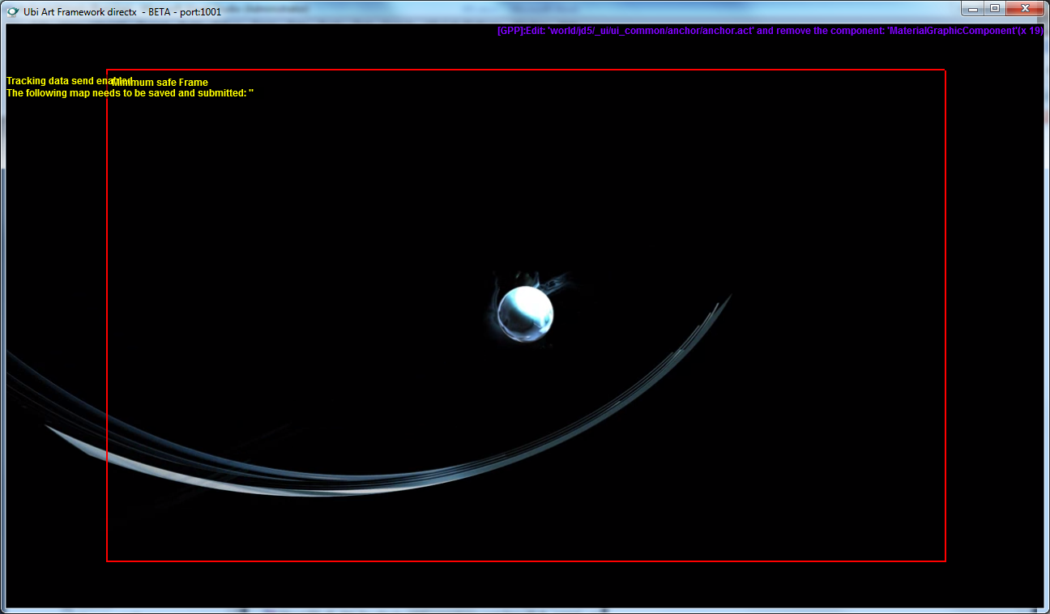

Main start
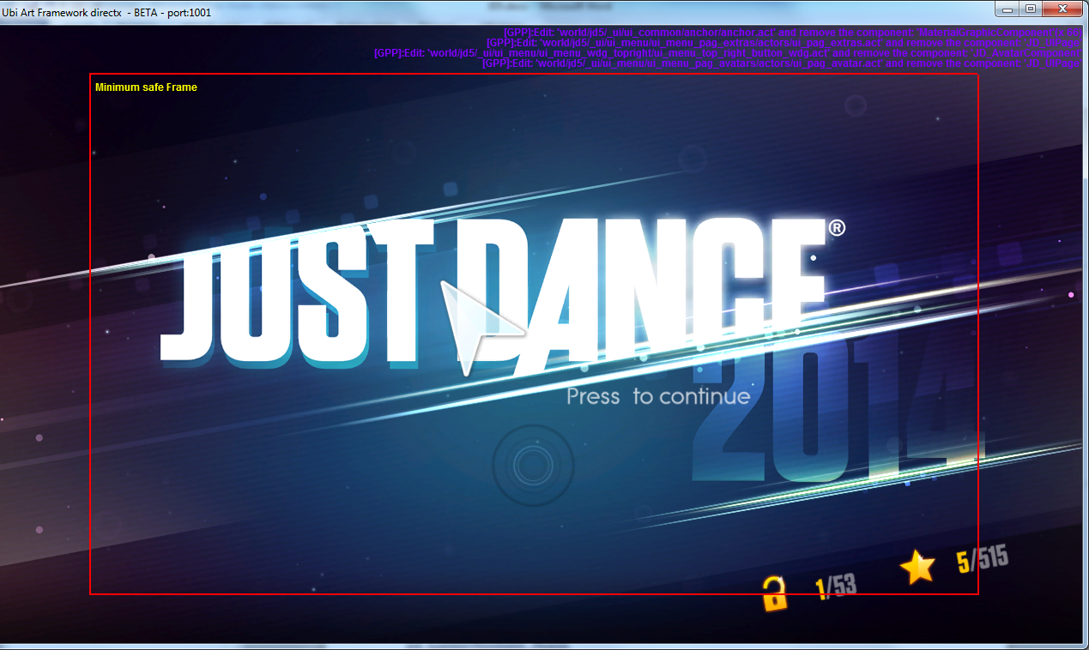

Main coverflow
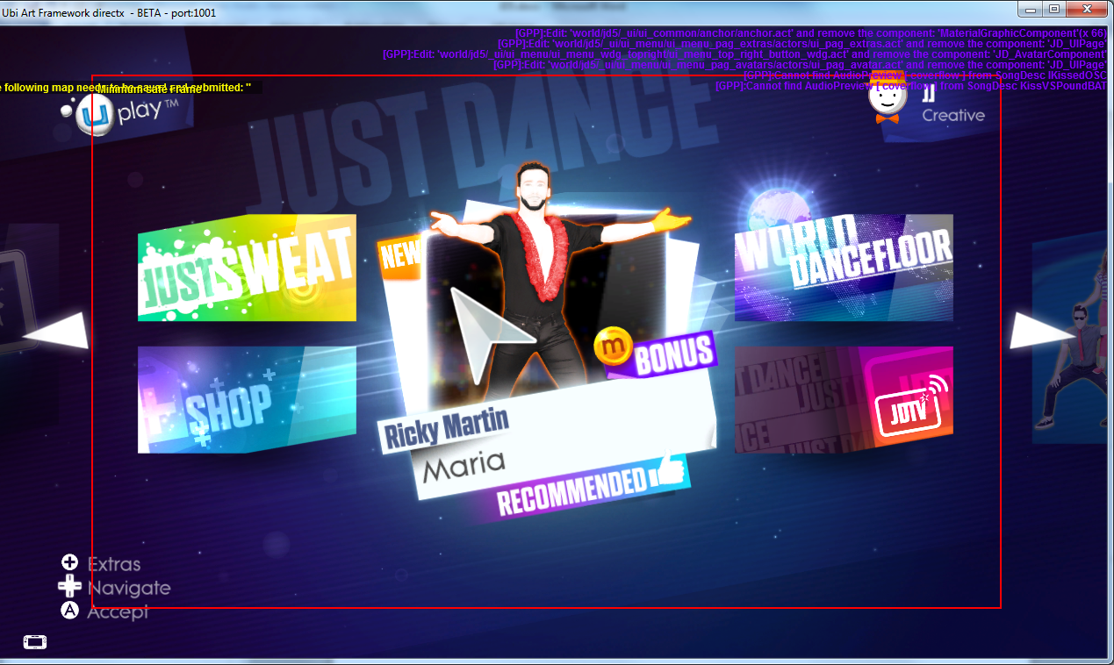

Shop module
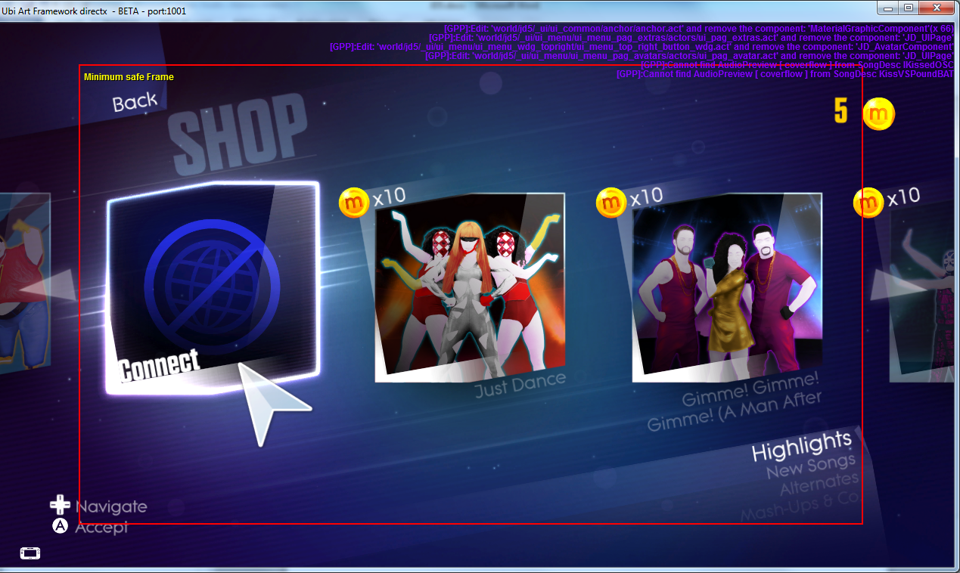

Extra page
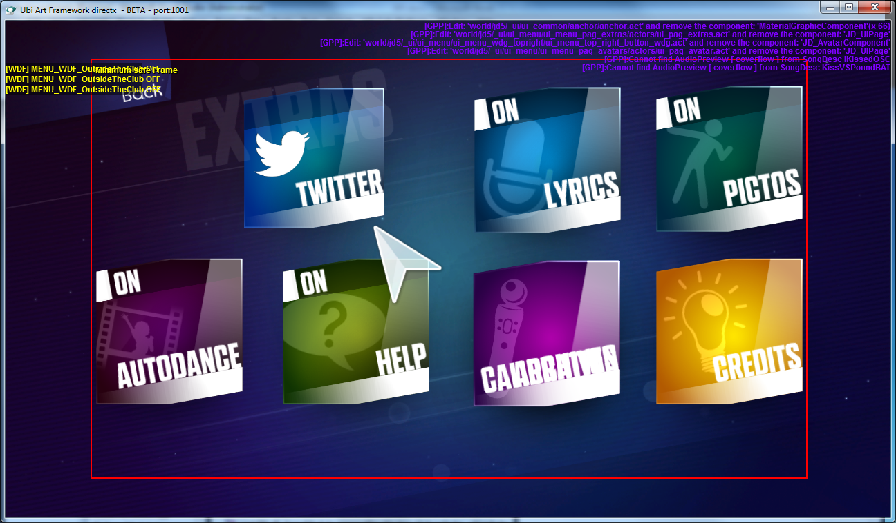

Prelobby
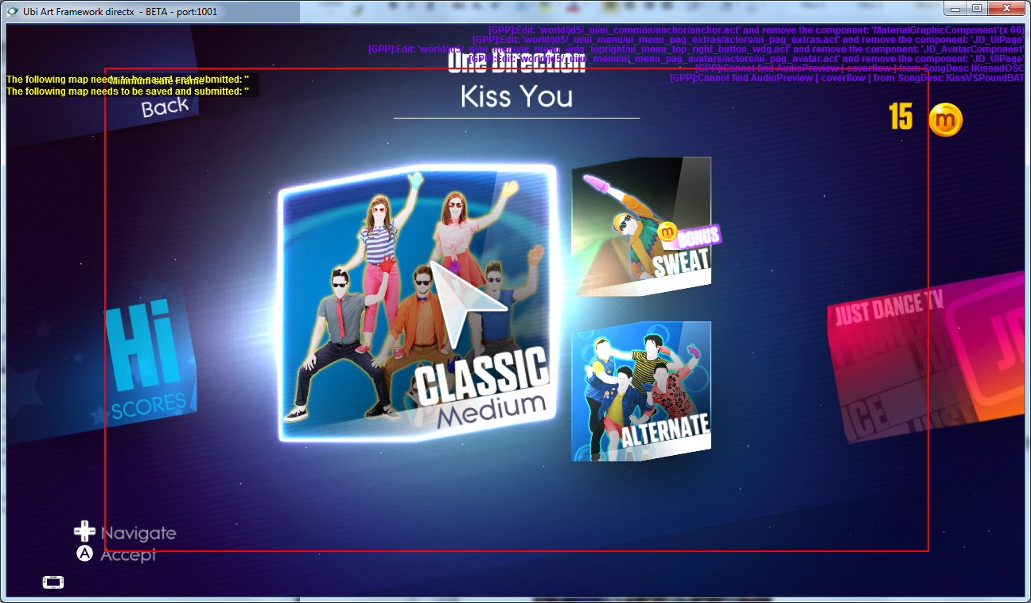

Lobby
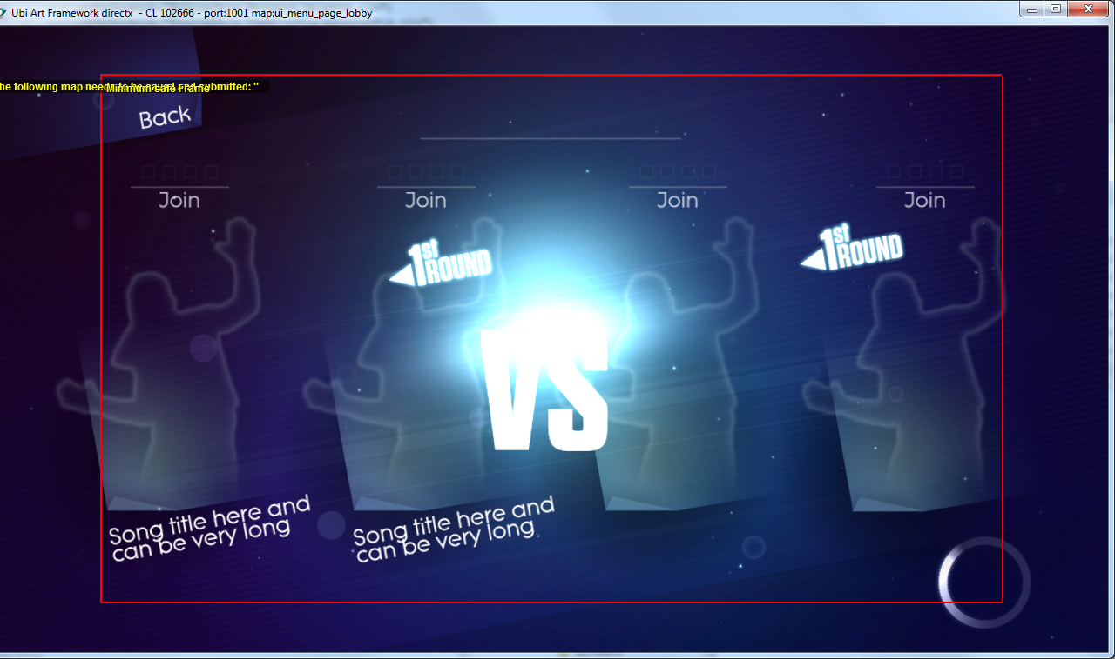

Game structure

Entry point
On PC, the entry point is
ITF_AppFramework/Win32/itf_main_win32.cpp

Main loop
ITF_AppFramework/Win32/application_framework.cpp

void ApplicationFramework::updateSingle()

Game Manager loop
Gameplay/ITF_Gameplay_JD/Managers/JD_GameManager.cpp

void JD_GameManager::update( f32 _dt )

Game modules manager loop
The Game manager will update the Game modules manager which will update each module
Gameplay/ITF_Gameplay_JD/Managers/JD_GameModulesManager.cpp
void JD_GameModulesManager::update( f32 _dt )

List of module
The list of modules is defined in
void JD_GameModulesManager::createGameModules()
You can find for example:
- JD_GameModule_BootSequence
- JD_GameModule_Main
- JD_GameModule_Recap
- JD_GameModule_Shop
- JD_GameModule_Dancercard
- …

Navigation
Navigation between game modules is done with the coverflow.
Coverflow works with Nodes and Connections
In JD_GameModule_Main you can find several node creations and connections.
void JD_GameModule_Main::setupNodesFlow()
{
// create main coverflow node
setFlowNode(EGM_Main_Coverflow , newAlloc(mId_GameplayMisc, JD_GM_FlowNodeScreen("Main_Coverflow", this, GAMEINTERFACE->getGameScreenFactory()->CreateObject<JD_GS_Coverflow>(JD_GS_Coverflow_CRC))));

// create extra page node
setFlowNode(EGM_Main_Extra , newAlloc(mId_GameplayMisc, JD_GM_FlowNodeScreen("Main_Extra", this, GAMEINTERFACE->getGameScreenFactory()->CreateObject<JD_GS_Extra>(JD_GS_Extra_CRC))));

// create credits page node
setFlowNode(EGM_Main_Credits , newAlloc(mId_GameplayMisc, JD_GM_FlowNodeScreen("Main_Credit", this, GAMEINTERFACE->getGameScreenFactory()->CreateObject<JD_GS_Credits>(JD_GS_Credits_CRC))));

// connect main coverflow to extra page
connectFlowNodes(EGM_Main_Coverflow, EGM_Main_Extra, EGMFlowConnection_TwoWays, "CoverFlowToExtra");

// connect extra page to credits page
connectFlowNodes(EGM_Main_Extra, EGM_Main_Credits, EGMFlowConnection_TwoWays);
}

Main_Coverflow
Main_Extra
Main_Credits
CoverFlowToExtra

Node
In a node there are GameScreens (ex: JD_GS_Coverflow). In a Game screen there are GameScreenState (ex : JD_GSS_PrepareCoverflow, JD_GSS_UnprepareCoverflow)
Node

GameScreen
GSS
GSS

GameScreen (GS)
In a Game Screen you can create connection to other screens
void JD_GS_Coverflow::createFlowConnections( JD_GM_FlowNode* _node )
{
Super::createFlowConnections(_node);
_node->addConnection(StringID("lobbyJustDanceDJ"));
_node->addConnection(StringID("prelobby"));
_node->addConnection(StringID("wdf"));
_node->addConnection(StringID("shop"));
_node->addConnection(StringID("sweat"));
_node->addConnection(StringID("jdtvhome"));
_node->addConnection(StringID("dancercard"));
_node->addConnection(StringID("uplay"));
_node->addConnection(StringID("CoverFlowToExtra"));
_node->addConnection(StringID("parentalControl"));
_node->addConnection(StringID("lobby"));
_node->addConnection(StringID("uplay_connect"));
_node->addConnection(StringID("uplay_tandc"));
}

GameScreenState (GSS)
A Game Screen has several states:
- Prepare
- Enter
- ActiveMainLoop
- Leave
- Unprepare
For each state we can define several GameScreenStates (ex: JD_GSS_UpdateCoverflow)
In a GameScreenState we can catch User event, like “press button”, refresh the screen state display…

For example, when we press start button the game will switch to Extra page
void JD_GSS_UpdateCoverflow::receiveInput(…)
{
if(_playerId == PLAYER_0 && _action == JD_GM_actionID_PressStart)
{
if (m_gameScreen->isConnectionReady("CoverFlowToExtra"))
{
processConnection("CoverFlowToExtra");
return;
}
}

}

But to change page, it is more common to use change page component

Display

GameConfig
To display game scene, we need to link code to the data. We can find these links in
X:\JD5\main\data\EngineData\GameConfig\gameconfig.isg.

In this file we can find reference to several *.ilu files
includeReference("EngineData/GameConfig/gc_common_ui.ilu")
In .ilu file you can find a link to the scene
{KEY="startpage", VAL = "world/jd5/_ui/ui_menu/ui_menu_pag_home/ui_menu_pag_home.isc"},
{KEY="coverflow", VAL = "world/jd5/_ui/ui_menu/ui_menu_pag_cvf/ui_menu_pag_cvf.isc"},

Scene
A scene is a XML file. If you edit it in a text editor, you will find Actors and Components

Actor
An actor has an .act file and a .tpl file which contains several actor data. This part is more for artists.
<Actor …

INSTANCEDATAFILE="world/jd5/_ui/ui_menu/ui_menu_pag_home/ui_wdg_home_fullpress/ui_wdg_fullpress.act"

LUA="world/jd5/_ui/ui_menu/ui_menu_pag_home/ui_wdg_home_fullpress/ui_wdg_fullpress.tpl">

Component
An actor has several components
<COMPONENTS NAME="JD_UIWidgetGroupMenu_ChangePage">
<JD_UIWidgetGroupMenu_ChangePage destination="next" >
A component is attached to the code. So you can find
Gameplay/ITF_Gameplay_JD/components/JD_UIWidgetGroupMenu_ChangePage.cpp file.

The component can handle event performed on the actor to refresh it or trigger special event for the whole game.

