View system
In order to get good performance in terms of memory and cpu we try to load and process as less as possible. To achieve this our gameplay entities are registered in the worldupdate and this object will take care of loading the resources and/or updating only that which is necessary. This is implemented through a system of views, each with a frustrum and some properties, which will allow us to gather the required entities from the 3d space.
Normally we have 3 views:
- Main view: the normal gameplay view.
- Remote view: for the remote camera of the DRC in the case of the WiiU (not available on other platforms).
- Editor view: enabled when we move in editor mode.

The first two are always there, so their frustum is always used to gather elements. The editor view is only used when you move in editor camera mode.
We have two types of views:
- Camera view: it has two frustum ranges, a big one and a smaller one. All the elements inside the big one will be asked to load its resources. The ones inside the small one will be asked to update as soon as their resources finish loading. (so resources+update)
- Resource view: this only uses one range. All the elements inside the frustum will be asked to load its resources and nothing more. (so resources only). This is used for example when we want to prefetch a part of the map, in case we want to teleport to it.

The 3 default views are created at the start of the game. Other views may be created and deleted in runtime, but it’s important to handle this nicely (create them at the right time and destroy them always when not needed).
In order to debug this system we have a few tools available. Whenever you go in the editor camera mode you will see a text label with the current active views at the bottom left part of the screen:
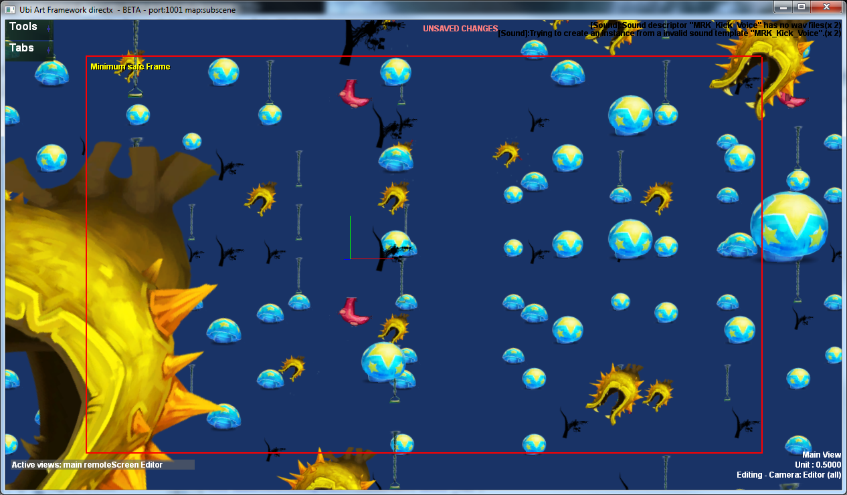

This is telling you that currently the gameplay, drc and editor view frustums are used to know which elements must load its resources or update.
At any point you can disable one of the first two views if you want, in case you want to rely only on what the editor camera is seeing. To do this access the debug menu with Alt+RightClick and go to Views:
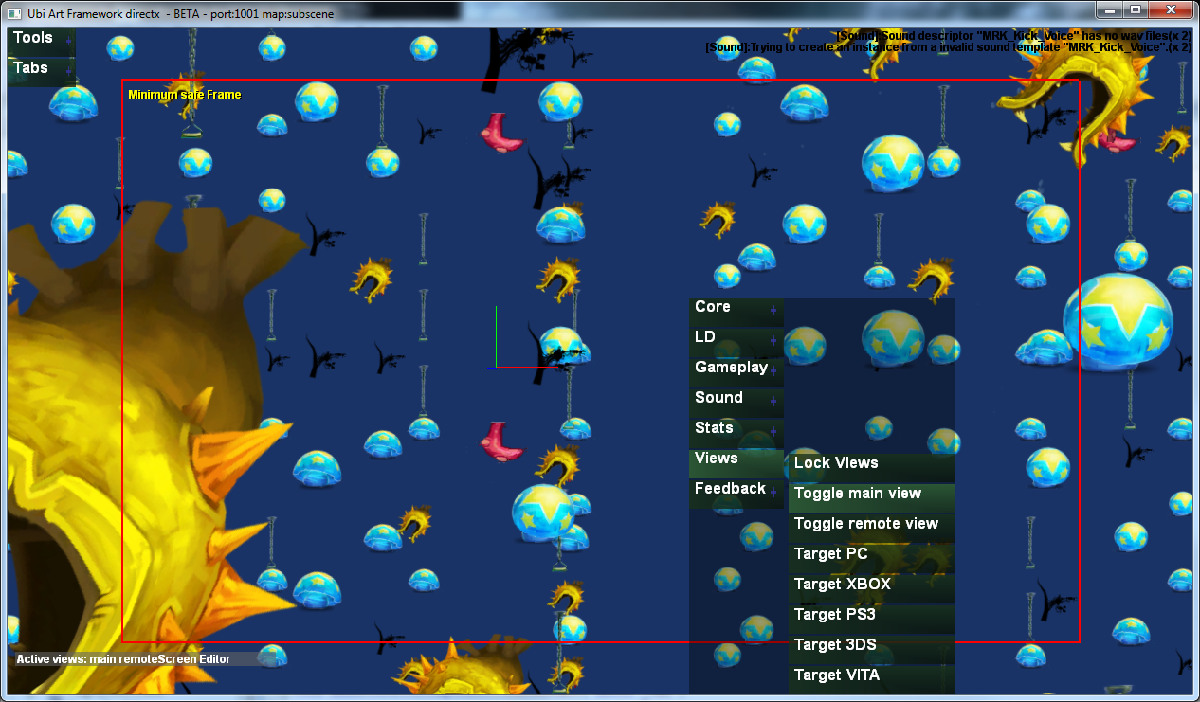

The text will update with the views that are enabled or disabled.
Additionally, Neil implemented a method to lock the views. What will happen is that the WorldUpdate will memorize the current views, and only use those to gather the elements that have to update or load its resources. The option is available at the same View menu from before (with Alt+Right Click).
Once you lock the views you are free to move the camera editor, the world update won’t change and you will be able to see exactly what is loading or updating. To enable the debug rendering just press ‘J’ and you will see the objects updating in green and the objects not updating but with resources loaded in red.

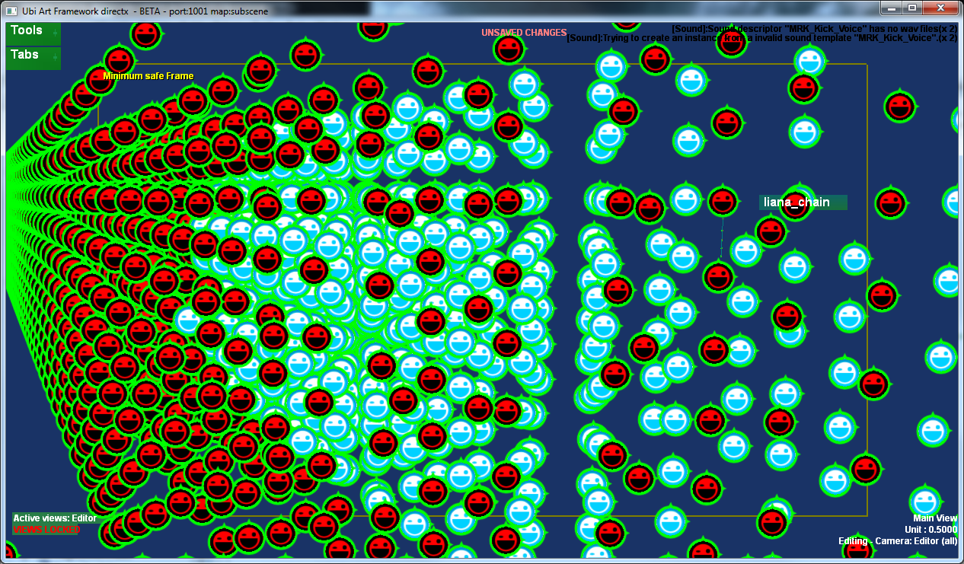

Regarding gameplay, there are some situations in which we need to update a group of actors at the same time. In order to do this we can mark a subscene actor as a synchronized group. What happens when you do this is that the content of the subscene actor is not registered in the octree, only the subscene actor is. The subscene actor acts as a manager for its contents, so if he is asked to load its resources it will propagate the load to its content. If its asked to update, it will wait until all the content is physically loaded, and then it will start to update it.

