Basics of MonophonicSynth, a substractive synth

SynthSignal

A SynthSignal is a class which returns a float pair with each value between -1 and 1:
The main method for a signal is
getNextStereoValues

which returns a
SynthSignal::StereoValue
structure which contains both left and right signals.
Signals can be combined together to build more complex signals, in a one way graph.
Signals can implement the following methods, if this is needed for the signal:
virtual void startPlaying( const StartState _startState );
virtual void requestStop();
virtual void setFrequency( const f32 _frequency );
virtual void setDetune( const f32 _detune );

The startPlaying method is particularly important to reset - or not reset - a signal when a note is started again (for instance for the portamento/glide behavior).
These methods must be transmitted to the child signals when in a graph.

Basic Signals
Here’s a list of the basic signal classes:
- SineSignal;
- TriangleSignal;
- SquareSignal;
- SawtoothSignal;
- NoiseSignal (random)

Routing Signals
Routing signals are used to route signals from one to another and to apply effects.

SignalWithBiquad
SignalWithBiquad is a signal with a biquad.
The methods to be used are:
To route a signal to it:
inline void setSynthSignal( SynthSignal * _signal );

The filter is a biquad, and its frequency goes through ADSR, it also has LFO:

inline void setBiquadFilterType( const FilterBase::FilterType _type )
inline void setBiquadInitialFrequency( const f32 _initialFrequency )
inline void setBiquadFrequencyFactor( const f32 _frequencyFactor )
inline void setBiquadQuality( const f32 _quality )
inline void setBiquadAttackDuration( const f32 _durationMilliseconds )
inline void setBiquadDecayDuration( const f32 _durationMilliseconds )
inline void setBiquadSustainValue( const f32 _value )
inline void setBiquadReleaseDuration( const f32 _durationMilliseconds )

inline void setBiquadFrequencyLFOFrequency( const f32 _frequency )
inline void setBiquadFrequencyLFOFactor( const f32 _lfoFrequencyFactor )

SignalWithDoubleBiquad
SignalWithDoubleBiquad is a signal with two biquads: Basically it’s quite similar to SignalWithBiquad, but the input signal is separated in 2 and routed to 2 biquad filters.
The methods to be used are:

To route a signal to it:
inline void setSynthSignal( SynthSignal * _signal )

Filter A params , ADSR and LFO:
inline void setBiquadAFilterType( const FilterBase::FilterType _type )
inline void setBiquadAInitialFrequency( const f32 _initialFrequency )
inline void setBiquadAFrequencyFactor( const f32 _frequencyFactor )
inline void setBiquadAQuality( const f32 _quality )
inline void setBiquadAAttackDuration( const f32 _durationMilliseconds )
inline void setBiquadADecayDuration( const f32 _durationMilliseconds )
inline void setBiquadASustainValue( const f32 _value )
inline void setBiquadAReleaseDuration( const f32 _durationMilliseconds )
inline void setBiquadAFrequencyLFOFrequency( const f32 _frequency )
inline void setBiquadAFrequencyLFOFactor( const f32 _lfoFrequencyFactor )
inline void setBiquadAQualityLFOFrequency( const f32 _frequency )
inline void setBiquadAQualityLFOFactor( const f32 _lfoFrequencyFactor )

Filter B params and ADSR (no LFO):
inline void setBiquadBFilterType( const FilterBase::FilterType _type )
inline void setBiquadBInitialFrequency( const f32 _initialFrequency )
inline void setBiquadBFrequencyFactor( const f32 _frequencyFactor )
inline void setBiquadBQuality( const f32 _quality )
inline void setBiquadBAttackDuration( const f32 _durationMilliseconds )
inline void setBiquadBDecayDuration( const f32 _durationMilliseconds )
inline void setBiquadBSustainValue( const f32 _value )
inline void setBiquadBReleaseDuration( const f32 _durationMilliseconds )

Set amount of filter A :
void setAmountA( const f32 _amountA );

DoubleSignalWithDetune
DoubleSignalWithDetune has two input signals, and has a detune and and interval.
The method setDetune is used to set slightly different frequencies on both signals, while the method setInterval is used to set a musical interval (a major or minor third, a fifth).
This class also operates a left/right mix to enlarge/reduce the stereo image.
The methods to be used are:
inline void setSynthSignalA( SynthSignal * _signalA )
inline void setSynthSignalB( SynthSignal * _signalB )

virtual void setDetune( const f32 _detune );
void setInterval( const f32 _interval ); // 1.33333 for a fourth, 1.5 for a fifth...
void setStereoWidth( const f32 _width ); // 0 - 1 : 0 mono signal - 1 largest stereo

ADSR
ADSR is an envelope with Attack Decay Sustain and Release, which returns a float between 0 and 1.
The methods which can called are:
inline void setAttackDuration( const f32 _durationMilliseconds )
inline void setDecayDuration( const f32 _durationMilliseconds )
inline void setSustainValue( const f32 _value )
inline void setTremoloDuration( const f32 _durationMilliseconds )
inline void setReleaseDuration( const f32 _durationMilliseconds )

Attack is the duration for the signal to go from 0 to 1;
Decay is the duration for the signal to go from 1 to sustain level.
Sustain is a level between 0 and 1.
Release is the duration to stop a note, from its current level to 0.
When a note is started, the attack is played, then the decay, then the level stays at the sustain level.
When a note is stopped, the levels gradually goes back to 0, even if the attack or the decay is not finished.
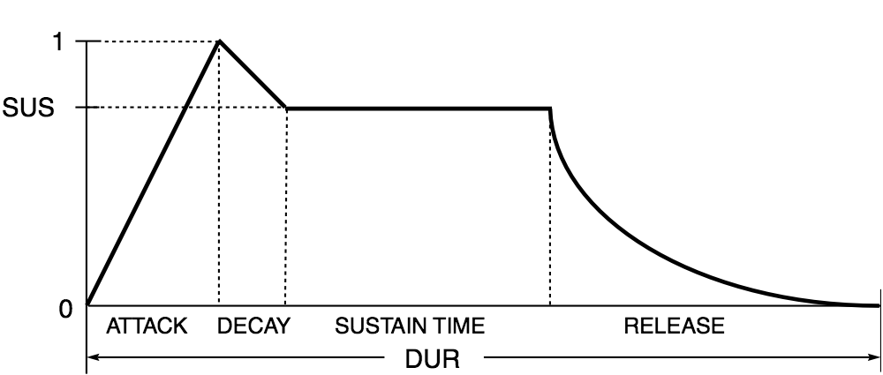

Current MonophonicSynth
The current MonophonicSynth uses the following graph:
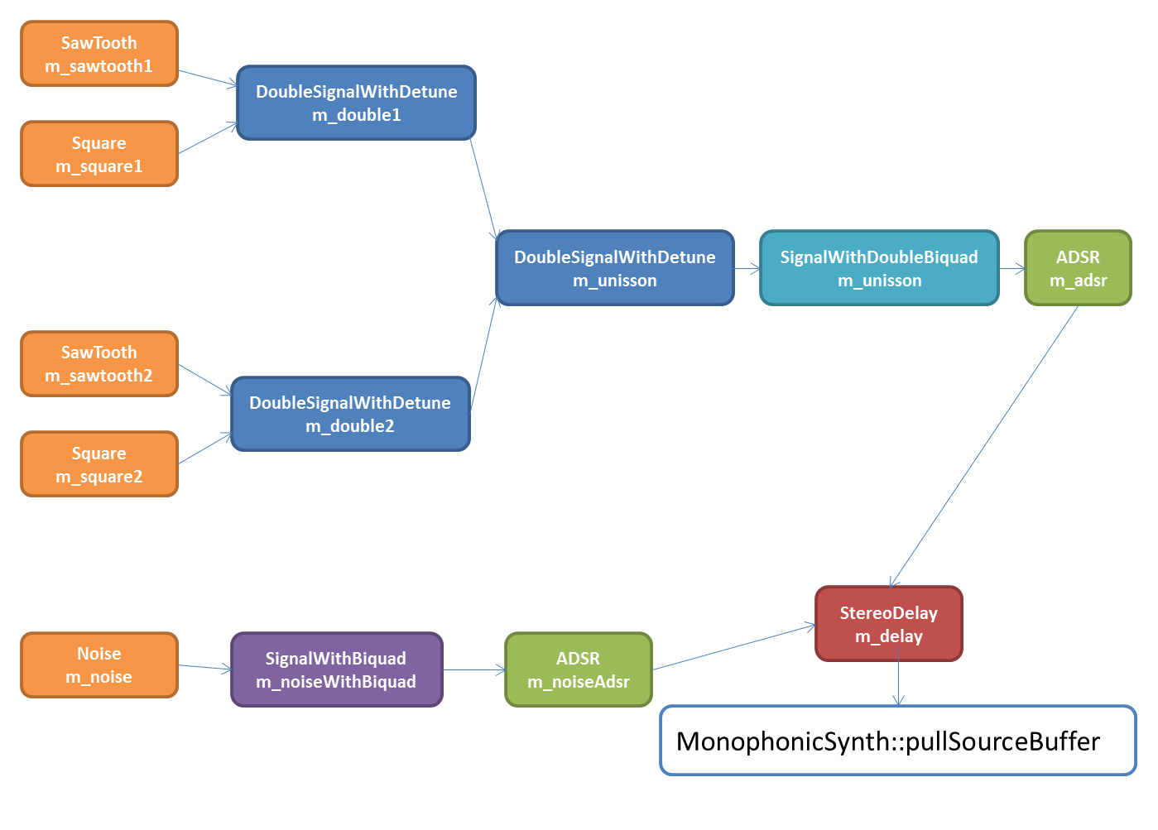
All parameters can be modified in the MonophonicSynth constructor:

MonophonicSynth::MonophonicSynth()
{
// set sound parameters here

setVolume( 3.f );
setNoiseVolume( -30.f );
m_double1.setSynthSignalA( &m_sawtooth1 );
m_double1.setSynthSignalB( &m_square1 );

m_double2.setSynthSignalA( &m_sawtooth2 );
m_double2.setSynthSignalB( &m_square2 );

m_unisson.setSynthSignalA( &m_double1 );
m_unisson.setSynthSignalB( &m_double2 );
m_unisson.setDetune( 1.001f );

m_signal.setSynthSignal( &m_unisson );

m_signal.setBiquadAFilterType( FilterBase::LowPass );
m_signal.setBiquadAInitialFrequency( 300.f );
m_signal.setBiquadAFrequencyFactor( 5.f );
m_signal.setBiquadAQuality( 1.8f );
m_signal.setBiquadAAttackDuration( 1700.f );
m_signal.setBiquadADecayDuration( 4000.f );
m_signal.setBiquadASustainValue( 0.5f );
m_signal.setBiquadAReleaseDuration( 1000.f );
m_signal.setBiquadAFrequencyLFOFactor( 0.3f );
m_signal.setBiquadAFrequencyLFOFrequency( 2.0f );

m_signal.setBiquadBFilterType( FilterBase::HighPass );
m_signal.setBiquadBInitialFrequency( 6000.f );
m_signal.setBiquadBFrequencyFactor( -0.95f );
m_signal.setBiquadBQuality( 0.5f );
m_signal.setBiquadBAttackDuration( 600.f );
m_signal.setBiquadBDecayDuration( 6000.f );
m_signal.setBiquadBSustainValue( 0.3f );
m_signal.setBiquadBReleaseDuration( 1000.f );

m_signal.setAmountA( 0.8f );

m_adsr.setAttackDuration( 80.f );
m_adsr.setDecayDuration( 1000.f );
m_adsr.setSustainValue( 0.82f );
m_adsr.setReleaseDuration( 1000.f );

// noise

m_noiseWithBiquad.setSynthSignal( &m_noise );
m_noiseWithBiquad.setBiquadFilterType( FilterBase::LowPass );
m_noiseWithBiquad.setBiquadQuality( 0.5f );
m_noiseWithBiquad.setBiquadInitialFrequency( 2000.f );

m_noiseAdsr.setAttackDuration( 50.f );
m_noiseAdsr.setDecayDuration( 150.f );
m_noiseAdsr.setSustainValue( 0.f );
m_noiseAdsr.setReleaseDuration ( 150.f );

// delay

m_delay.allocateMemory( 48000 );
const f32 bpm = 136.f;
const f32 beatDurationMilliseconds = 1000.f * 60 / bpm;
m_delay.setDelayDurationMilliseconds( beatDurationMilliseconds / 1.f );
m_delay.setDamping( 0.4f );

